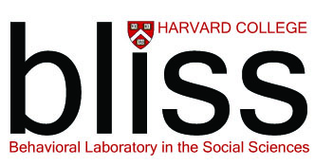
Application Deadline:
5:00pm Wednesday, February 22, 2017
APPLICATION SUPPLEMENT FORM Please respond in type in the spaces below.
Name (LAST NAME IN CAPS, First name, M.I.) |  | Class: |  | Permanent (non-Harvard) e-mail address:
House/Yard affiliation: |  | HUID: |  | Concentration (declared or likely):
Please indicate your preferences among BLISS projects, as described at http://www.fas.harvard.edu/socsci/BLISS2015Projects.html
1st choice faculty host: | Project title:
2nd choice faculty host: | Project title:
3rd choice faculty host: | Project title:
Do you have any obligations this summer that may preclude your full commitment to participation in BLISS for the full ten weeks of the program (June 5-August 11)? If so, please elaborate briefly.

Is summer 2017 the only summer during your undergraduate studies that you will be able to participate in BLISS? If so, please elaborate briefly.

In a separate document, please provide responses to the following three statements. Please be sure to include your name at the top of the page(s).
Describe why you are interested in participating in BLISS and how your preferred project(s) relate to your academic goals. (500 words maximum)
Describe how you expect that participating in BLISS will inform your academic trajectory or contribute to your professional goals. (300 words maximum)
Describe how you will contribute to, and benefit from, the BLISS community of researchers. (300 words maximum).

SIGNATURE REQUIRED
PLEASE SUBMIT ALL APPLICATION MATERAILS TO CARAT AT https://apps2.registrar.fas.harvard.edu/carat/.
DEADLINE: WEDNESDAY, FEBRUARY 22, 2017
I affirm that the foregoing statements and attached materials are true and accurate representations of me and my application to BLISS.
Entering your name in this space affirms your signature: |  |  | Date:

