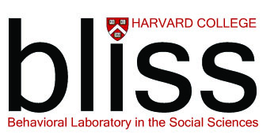

Deadline:
5pm, Wednesday, February 22, 2017

INSTRUCTIONS FOR THE ACADEMIC / RESEARCH RECOMMENDER
FROM THE BLISS SELECTION COMMITTEE

Applicant Name:

This applicant is applying to the Harvard College Behavioral Laboratory in the Social Sciences (BLISS), to participate in the 10-week summer residential community of undergraduate researchers. A critical factor in evaluating the application is evidence of initiative and motivation in an academic and/or research setting. The applicant has selected you to provide a letter of recom- mendation to the BLISS Selection Committee, and we thank you for your effort on the applicant’s behalf. We would appreciate it if you would address the following questions in your letter:

1. In what capacity do you know the applicant?

2. Can you provide brief examples of initiative, motivation, and determination in an academic and/or research activity?

3. How would the applicant benefit from and contribute to the BLISS community?

4. If you are a BLISS project sponsor, please comment on the applicant’s qualifications for BLISS generally as well as for your project specifically.

You will receive an email prompt generated by the Centralized Application for Research and Travel (CARAT) after the applicant has invited you to submit a recommendation. Simply follow the directions to upload a signed pdf version of your letter on official institutional stationary to the CARAT online link indicated on the invitation.

The deadline for receipt of application materials is Wednesday, February 22, 2017. If you have any questions, please contact the Assistant Director of Undergraduate Research and Fellowships, Cammi Valdez, at cvaldez@fas.harvard.edu.

Harvard College | Office of Undergraduate Research and Fellowships
77 Dunster Street | Cambridge, MA 02138
617-495-5095| http://uraf.harvard.edu/summer-residential-research-programs | undergradresearch@fas.harvard.edu

