Exhibition at PEM:
Investigating Current and Prospective Design Elements in and out of the Art Museum

presented by
Robert Fitzpatrick
Harvard Summer Practicum Student
Under the supervision of Dave Seibert
on August 15th 2014
Introduction

I have spent my summer at PEM in the Exhibition Design Department. Over the course of the internship, the focus of my research has evolved into the following report. At the very beginning of my time at PEM, my research began with Dave Seibert prompting me to read Dan Monroe’s New Directions. This essay details current tastes and demographics of museum-goers and how PEM could better conform to them. Basing a lot of his findings, beliefs, and ideas for the museum experience on the findings of Robert Lakota, Dan Monroe emphasizes how important it is for PEM to tap into and heighten the art museum experience for guests.
Using Dan Monroe’s mission to better the visitor experience as a starting point, I began comparing and contrasting the experiential structure of PEM with that of other museums. By seeing how other museums address the viewer, I could then evaluate what PEM could be doing differently in order to keep visitors engaged, excited, and comfortable during and after their visit.

Dave suggested that I explore non-art museums for my research. By visiting museums that did not focus on art, I was able to observe the universal ways in which people experience a museum, regardless of the institution’s subject matter. Whether a museum space focuses on science, history, or art, the visitors exhibit similar wants, needs, and behavioral patterns.

Throughout my observation process, I noticed four elements of the visitor experience that wildly vary in quality between museums: seating, interactive and textual information, atmospheric and environmental delineation, and social media. In the following report I describe the ways in which other museums address these four experiential areas and how PEM could better confront them.

Seating

Background:

Dave suggested seating as my first avenue of exploration, since it is an often-overlooked component of the visitor experience. He admitted seating is usually an afterthought in the exhibition designing process, leaving couches and chairs to be added after a cohesive plan is drawn and executed. This seating negligence may lead to disjointed, awkward seating arrangements that go unused as a result.

Since seating is mandatory in each gallery, finding preferable arrangements is beneficial for the museum as a whole. Not only is seating ubiquitous, but it can also have a direct impact on the physical and cognitive experience of PEM visitors. Physically, seating gives spectators reprieve from “museum feet” and other aches from walking and standing for extended periods of time. Cognitively, gallery seating should allow patrons to remain engaged with museum material by being situated with a focused view of artwork or interactive material.

PEM’s Seating with Turner and the Sea

Dave suggested I begin my seating research at Turner and the Sea. Here I would mold a basic understanding of PEM’s seating. By observing which seating configurations guests favored and which ones fell by the wayside, I would be able to better deduce which configuration styles are preferred by guests and which are not conducive to an optimal viewer experience. I studied the seating arrangements by noting which seats guests were drawn to and which they averted.

After studying Turner and the Sea I made a few discoveries about guests’ seating tastes noted here by room:

Turner on Show
- I did not observe anyone sitting on this room’s bench
  - Speculated reasons for non-use
    - No clear visual focus from seating
      - The wall closest to the bench (central wall in gallery) bears two paintings, with the view from the bench landing in the negative space between the two paintings lack of focus
    - This is the first gallery room in the exhibit
    - Viewers are not yet tired
    - Viewers want to explore the rest of the exhibit before committing to one spot
    - Viewers have not yet seen a significant amount of the exhibit to sit and discuss what they have seen so far
    - The paintings closest to the bench are not particularly eye-catching
    - The bench is not close enough to any painting for focused viewing
    - Sitting in the middle of a viewing space is not appealing to viewers
M for Marine
- I did not observe anyone sitting on this bench
  - Speculated reasons for non-use
    - No clear visual focus from seating
      - The bench does not face any particular work head-on
    - The perpendicular nature of the bench to the central wall and glass case with book create an awkward arrangement
    - Since this is the second gallery room, viewers may not yet be tired
Contested Waters
- I did not observe anyone sitting on either bench
  - Speculated reasons for non-use
    - No clear visual focus from seating (especially for the bench in the back of the room; it lines up with the negative space between two paintings)
Trafalgar Squared/Contested Waters
- During my observation period, this was the most popular seating arrangement in the gallery, with many people sitting on the two benches
  - Reasons for popularity/use
    - The two benches are parallel with paintings
    - The two paintings parallel to the benches are very larger, with many details, provoking focused and detail-oriented gazing
      - These paintings elicit lots of looking, which may cause people to sit down in order to commit more time and better absorb the piece
    - The benches make logical sense in their arrangement and orientation
Imagining the Sea
- The central seating with the angled viewing counters were rarely used
  - Speculated reasons for non-use
    - The pathways between the counters create an ambulatory flow
    - The abstraction/lack of detail in these paintings do not elicit detail-oriented viewing from visitors
    - The dim lighting in the room does not invite detail-oriented viewing
    - Most people visiting the exhibit were in groups and these seats are quite insular
- The sidewall benched with iPads were quite popular for seating
  - Speculated reasons for use
    - The seating arrangements had an activity associated with them
    - They were in the ends of the room, allowing seated guests to view the whole space
    - The benches were against walls, which creates a cozier and more casual atmosphere
    - Since this gallery room is significantly deep into the exhibit, I supposed some visitors were tired and wanted to rest
Making Waves: Atlantic Crossing
- This seating arrangement had a fair amount of sitters, but less than the benches at the iPad stations and the Trafalgar room
  - Speculated reasons for popularity
    - Last room in the gallery
      - Visitors are tired
      - Visitors want to sit and discuss the exhibit in its totality
    - The square seating configuration is inviting
    - The security guard said that over the past three weeks it has been a very popular seating arrangement
    - Its central positioning and its position right in front of the room’s entrance give the seating a natural gravitational pull

Summary:

- The most popular seats in the exhibition were the two benches in the Trafalgar Squared room. These two seats were parallel with two hugely detailed painting. Sitting enabled guests to absorb, ingest, and digest the ample visual material for an extended period of time.

- Guests like seats that are against walls. Seating that is against the wall allows visitors to step out of the action of the gallery’s walking space for a few minutes so that they may decompress. A seat against a wall also creates a nice vantage point from which the guest can look over the whole gallery space.

- Large seating arrangements create social spaces, which guests use to discuss the exhibit’s material. The last seating arrangement in Turner and the Sea was a big square block of seating. This arrangement was big enough that guests did not feel cramped by each other, but were close enough for discourse.

- No bench away from a wall was used, unless there was a clear visual focus associated with the seating (Trafalgar Squared). I assume that people do not feel relaxed sitting on benches in the middle of a room; this leaves them surrounded by moving people and in a central location for visual scrutiny – almost as if an object sitting on a pedestal. I assume this to be true, because benches away from the wall were only used when placed near paintings that elicited detailed observation (Trafalgar Square), suggesting that people were not interested in seating arrangements away from the wall for physical reasons.
Learning from other Museums

Out of all the museums I visited, the Museum of Science had a seating arrangement that was used more than any other I observed. In one gallery, there were three couches that were placed in a U shape. Though they were away from the walls, these three couches created a comfortable and natural social space, which many people used for talking about the exhibit. Since guests were able to face each other as they spoke, they felt comfortable sitting and relaxing there for an extended period of time. The arrangement was also large enough that solitary people do not feel overpowered by the socializing of others sharing the space. There is also enough room for multiple small social groups to share the seating. (see picture below)

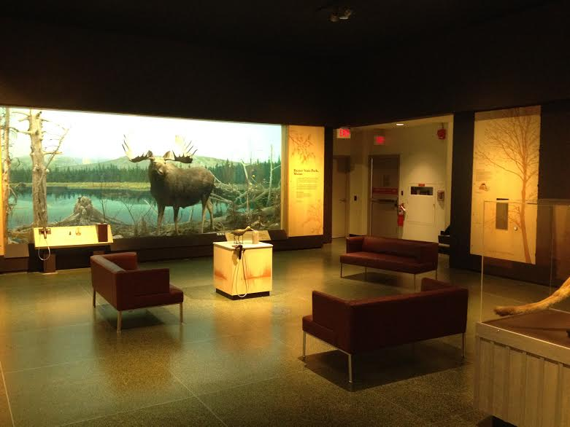

Interactive and Written Material

PEM Digital Interactive Material

The interactive iPad material in Turner was a major success with guests under 30 years of age. Each guest that I discerned as younger than thirty sat down at the accompanying bench and used the iPad program until it was complete. Though a hit with young patrons, guests visibly older than 50, on average, neither sat down to use the iPad program nor used the program until completion. Only two patrons older than 50 sat and fully used the program.

PEM Detail-Oriented Viewing Stations

In Turner’s “Imagining the Sea” room, the stools placed in front of Turner’s sketches and drafts were barely used. I surmise that there are three main reasons why these seats were not used for the intended focused viewing. 1) The roughly done sketches and drafts were not detailed enough to captivate extended viewing from the average guest, as seen in “Trafalgar Squared.” 2) The stools were insular and did not allow guests to devote extended time with one piece while also speaking about their observations with a friend. For comparison, most people who sat and used the iPads were sitting with a friend while they used the program. 3) The detailed viewing stations were not secluded enough to focus guests’ attention. The stations were placed in the center of the room, in ambulatory space. Also guests could clearly see each other from across the tilted counters that held the art pieces. The successful iPad material was stationed in the corner of the rooms, where people felt comfortable curling up and relaxing while using the material.

Other Museums and Detail-Oriented Viewing

The Old State House fails at this by placing a long conference table in the middle of a room and strewing historical documents across the surface. The objective is to allow guests to recreate the actions of an eighteenth century conference, but the lack of directive leaves this interactive unused and unpopular.

The Museum of Science had some very popular interactive stations. The commonality between the popular interactive stations was that they limited visual distraction. The popular interactive stations were either facing a wall or had built-in partitions, which focused patron visual focus and attention on the presented material. (see below)

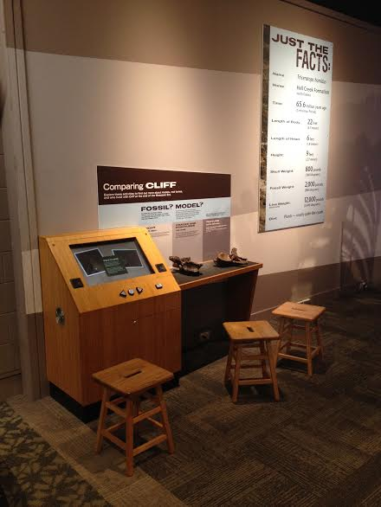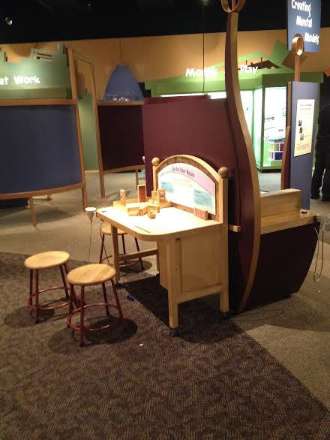

PEM Written Material

A majority of PEM’s information is written on plaques placed adjacent to the work to which it refers. Robert Lakota’s research finds that the average museum guest spends less than two seconds reading such placards. Thus, patrons may not read a majority of written information at PEM.
Other Museums and Written Material

Like PEM, the Boston Children’s Museum displays a lot of information via written text on walls. The Children’s Museum addresses the short attention spans of patrons, however, by pre-chewing the information for them. Informational placards are broken down into bullet points. While bullet points make it easier for patrons to skim, they also make the body of text seem more manageable than getting to the bottom of a daunting block of text.

The Children’s Museum also capitalized on wall space in hallways and other “dead zones” by displaying text with useful information that patrons could use outside of the museum, by discussing everyday behavior and actions (ex. recycling, water conservation). Though there is absolutely no guarantee that a visitor heeds the advice given, this plaque at least prompts the visitor to think about this information after leaving the museum. This is a future investment in the visitor – by asking the visitor to modify behavior outside of the museum, the plaque implicitly reminds the visitor to think of the Museum even after leaving. I suggest that if a space is too awkward, small, or tight for a work of art in PEM, use the space to engage with visitors in creative ways. Art museums need not only exhibit present art, but can talk about any aspect of art in general. For example, use this space to teach about the various ways people buy, deal, create, store, etc art. Or fun facts about the site of PEM. Bring up the history of the building that the visitors are currently in. Plaques or displays that provide tips/information that applies to visitors once they leave the museum will plant a seed that will remind visitors of the museum once they utilize or remember the tip/info. For example, if a plaque taught visitors how to frame/display their own photos at home, once visitors are putting up pictures in their home, they will remember this tip and, by transitive property, PEM. Hopefully, since this info was helpful to them, the visitors will want to thank PEM somehow, or at least visit it again.

The Old State House displays some tidbits of text by placing them about three feet off the ground. By doing this, the museum directly engages with children and makes the space seem more family friendly!

Atmospheric and Environmental Delineation

Background:

While I travelled through the museum, I felt like there lacked transitional ties between spaces, especially between spaces that exhibit art from vastly different time periods and cultures. I think that PEM best treats transitional space with the blue and white porcelain-inspired staircase. This aesthetically connects multiple spaces and creates cohesive travel between them. In other spaces, there is less palpable transitional space, leaving a confusing juxtaposition of art spaces. With the areas of the museum that don’t have transitional space, the atmospheric shift between spaces does not naturally bleed into one another. For example, the Herwitz Gallery seems disjointed – I wonder why I leave an open space dominated by nautical figureheads and enter into a small space filled with contemporary Indian pieces.

Creating multiple “worlds” within the museum might be too daunting, especially within the permanent collection spaces. But I do think that this could at least be done within temporary exhibitions. I absolutely loved California Design but maybe more could have been done to cognitively and emotionally transport guests to golden age California. The walls, floors, sounds, smells, colors, &c. of the space can be curated and executed to make a world in which the exhibited objects are alive, not simply on display.

Transitional Space at the Children’s Museum

I’m sorry that I cannot offer specific solutions, but I will show you examples of how the Children’s Museum delineates spaces. In each space there is a distinct universe with its accompanying lessons. The museum uses the simplest transitional method – a street, with each gallery space being a building with a façade on this street – but there is something so effective about this construction. As I walk through the children’s museum, I know exactly what kind of space I am entering and what material I will learn about inside. On top of that, each space has its own heavy-handed aesthetic, creating a more intimate and engaging space. The exaggerated nature of each delineated space brings its associated objects to life, as they are presented in spaces imitating the objects’ natural habitats.

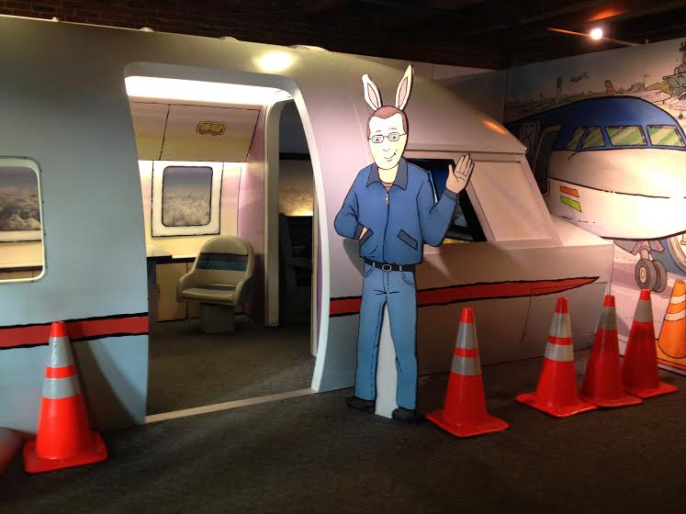

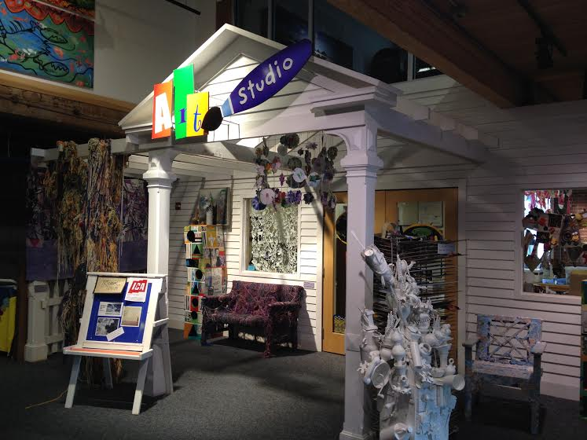

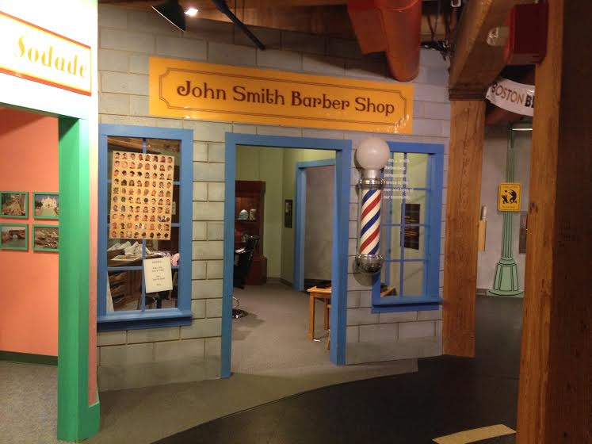

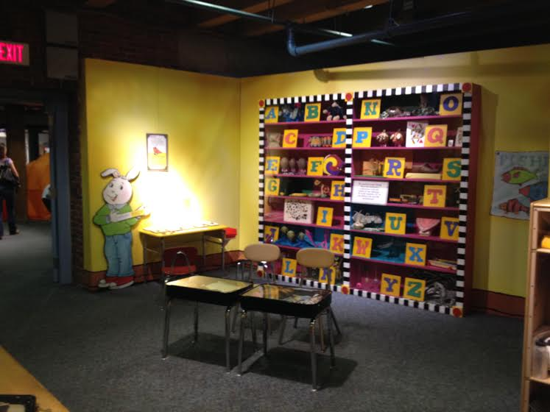

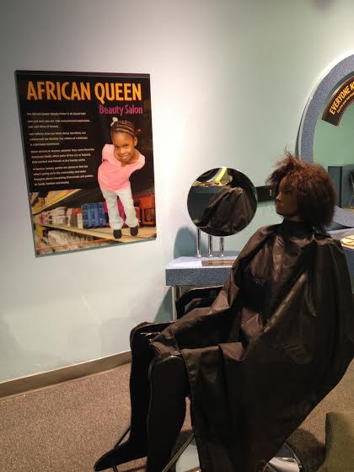

Social Media

PEM’s Social Media Presence

I know that PEM has social media accounts and uses them, but the museum should encourage its guests to use their social media while in the museum. If a person Instagrams a photo of something in PEM, that person’s followers will see a piece of PEM, which is free advertising. Though gimmicks are kitschy and border on tawdry, they can blow up. Think about the #strikeoutALS #icebucketchallenge. Videos of people pouring ice water on themselves went viral, ending up on virtually everyone’s Facebook newsfeed, and increasing ALS-foundations’ donations by more than 1000%. This example is clearly a rare circumstance, but people like posting and sharing funny pictures/videos of themselves on social media. If PEM integrates creative and funny photo opportunities in the museum, guests will exploit them. Just make sure that PEM splashes @peabodyessex near every good photo-op so that guests make sure to tag their photos upon upload. On top of advertising, taking silly pictures is a fun experience and can improve the overall visitor experience at the museum. Maybe PEM will have a surge of teens, a largely untapped demographic in art museums, coming just to take these instagrammable photos.

Old State House with New Presence

The Old State House Museum leaves hashtags next to artifacts to encourage tech savvy guests (almost everyone nowadays) to tweet and instagram about the museum. In one room there is even a chair with costume pieces and a wig, so that guests can take and upload goofy pictures. This would definitely increase how many people spread word of the museum on social media.

Conclusion

PEM is a great museum. It is a more inviting and cohesive space than any other museum I visited during my research. Though it is great, it naturally could, like all other things, improve. I admit that all suggestions I make are simply opinions that I formulated from my own observations, but I truly believe that they all could help the museum. More social seating arrangements, less distracting interactive spaces, bullet points on plaques, better defined environments, and a more pronounced social media presence could enhance the viewer experience. If, one day, all of these suggestions have been enacted with no avail, just hand out free food to guests – everyone loves free food. I hope these observations and suggestions are helpful to whoever reads this.

